4-Way Traffic Signal Controller Using Digital Logic and Timing Circuits
FCSE, Ghulam Khan Institute of Engineering Science and Technology, Pakistan


Course:
Digital Logic Design

Instructor:
Dr. Adnan Shah

Submitted by:
Emaan Fatima (2024154)
Emaan Tahir Swati (2024156)
Abstract
Traffic lights play a crucial role in ensuring road safety and managing vehicular flow at intersections. This project focuses on the design and implementation of a 4-way traffic signal system using digital logic components. The system regulates traffic at a four-way intersection by controlling the sequence of green, yellow, and red lights for each direction. Combining principles of digital logic, sequential circuit design, and timing control, this project aims to simulate real-world traffic scenarios effectively and provide a robust solution for traffic management challenges. The approach also lays the foundation for future advancements such as sensor-based traffic adaptation and wireless communication between traffic systems.
I. Introduction
Traffic control systems are essential in urban environments to manage the flow of vehicles efficiently and ensure safety. Unregulated intersections often lead to accidents, congestion, and inefficient vehicular movement. This project addresses these issues by developing a 4-way traffic signal system that employs digital logic components such as counters, timers, and logic gates. By simulating real-world traffic scenarios, the system highlights challenges in traffic management and provides a scalable, reliable solution.
The proposed system combines simplicity and functionality, offering a cost-effective alternative to more complex traffic management solutions. Digital logic components are utilized to design a robust control mechanism that ensures the sequential operation of traffic lights while maintaining a strict no-conflict policy. This work emphasizes both the theoretical and practical aspects of circuit design, offering insights into implementation and potential scalability for larger networks.
II. Objectives
- Design a 4-way traffic signal system for safe and efficient traffic management.
- Implement the system using digital logic components, including counters, timers, and logic gates.
- Simulate the operation of the traffic system to verify functionality before physical implementation.
- Enhance skills in designing and analyzing sequential circuits.
- Explore scalability and integration with advanced technologies such as vehicle detection sensors and IoT-based communication.
III. System Overview
The 4-way traffic signal system controls traffic at intersections by cycling through green, yellow, and red lights for each direction. The system is engineered to ensure fairness and efficiency in traffic flow distribution.
Key Features:
- Green Light: Allows safe passage for vehicles in one direction.
- Yellow Light: Cautionary signal before transitioning to red.
- Red Light: Signals vehicles to stop, allowing other directions to move.
A. Block Diagram Components:
- Pulse Generator: Provides timing signals for transitions, ensuring precise intervals for each light phase.
- Sequential Logic Unit: Ensures proper state transitions (Red → Yellow → Green) while avoiding conflicts.
- LED Indicators: Visual representation of traffic light states for simulation and demonstration.
- Control Logic: Guarantees that only one green light is active at a time, maintaining safety.
B. System Workflow:
The workflow begins with a clock pulse from the timer, driving the counters and initiating state transitions. Control logic verifies the sequence before activating LEDs to represent the respective light signals. Feedback loops ensure a continuous cyclic operation.
IV. Hardware Design
A. Components:
- 555 Timer:
- Generate timing intervals for light transitions.
- Configured in astable mode for clock pulses.
- Adjustable resistors and capacitors fine-tune timing.
- 4-Bit Decade Counter:
- Define intervals for green, yellow, and red lights.
- Cascaded counters extend timing ranges as required.
- LED Indicators:
- Represent traffic light states with high visibility and low power consumption.
- Resistors:
- Protect LEDs by limiting current and preventing damage.
- Transistors:
- Amplify current to drive LEDs when needed.
- Breadboard and Jumper Wires:
- Facilitate modular testing and prototyping.
B. Circuit Schematic:
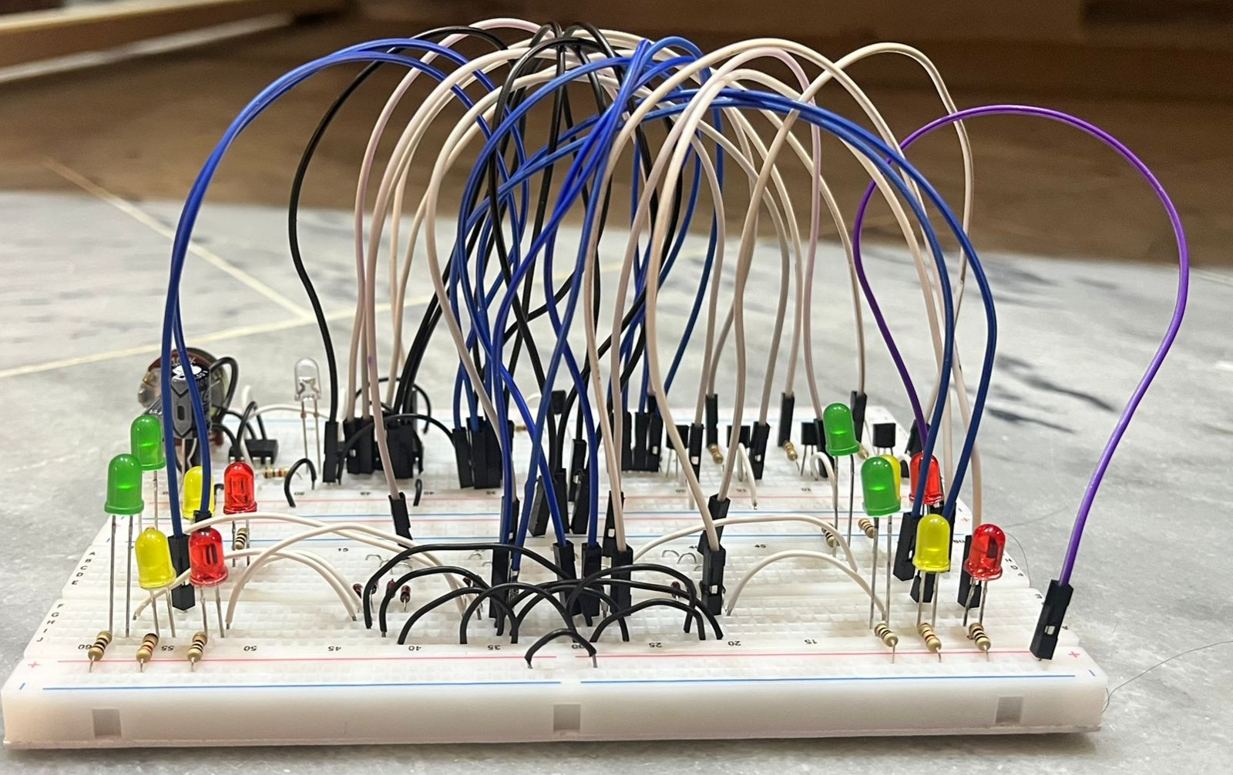
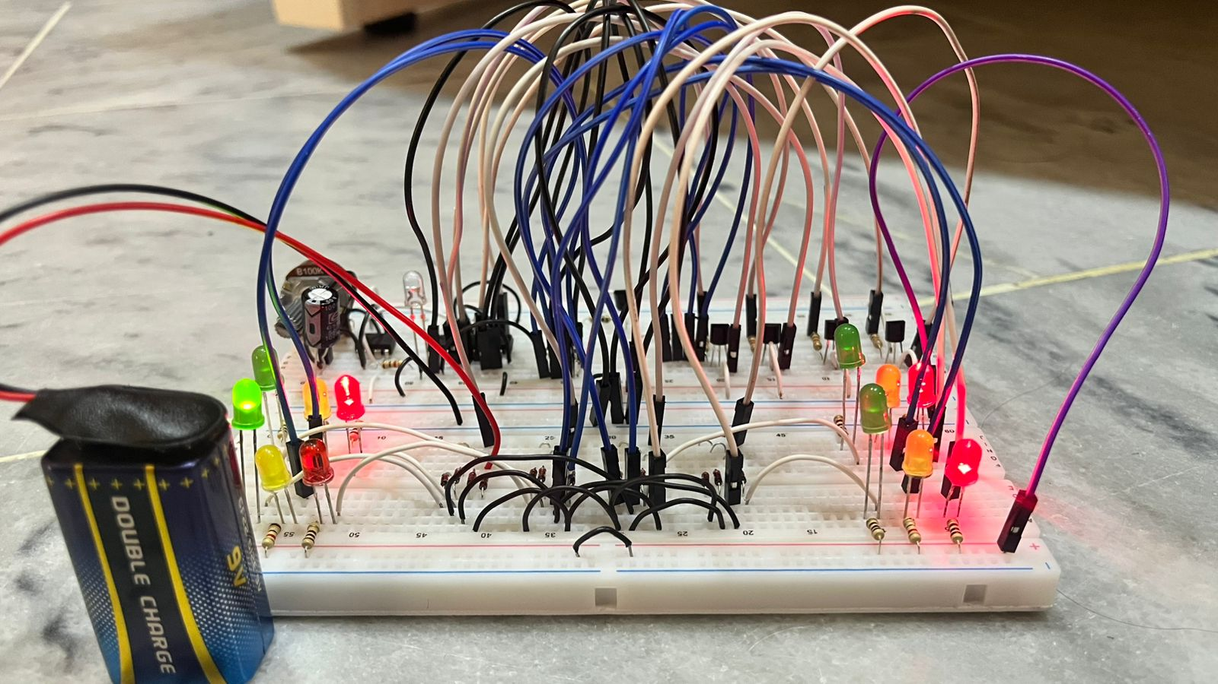
The hardware integrates timers, counters, and LEDs to create a functional traffic signal system. The clock pulse from the 555 timer drives the counters, which dictate the timing and sequence of the light states. Logic gates manage transitions, ensuring no two directions have green lights simultaneously.
V. Software Design and Simulation
Simulation tools such as Proteus validate the design before physical implementation. These tools provide a virtual environment to test system behavior and identify potential issues.
A. Steps:
- Circuit Design: Recreate the hardware schematic in the simulation software.
- Timing Configuration: Set timer intervals to match design specifications for green, yellow, and red lights.
- Functional Testing: Verify the light sequence and ensure smooth transitions.
- Adjustments: Fine-tune component values to optimize timing and functionality.
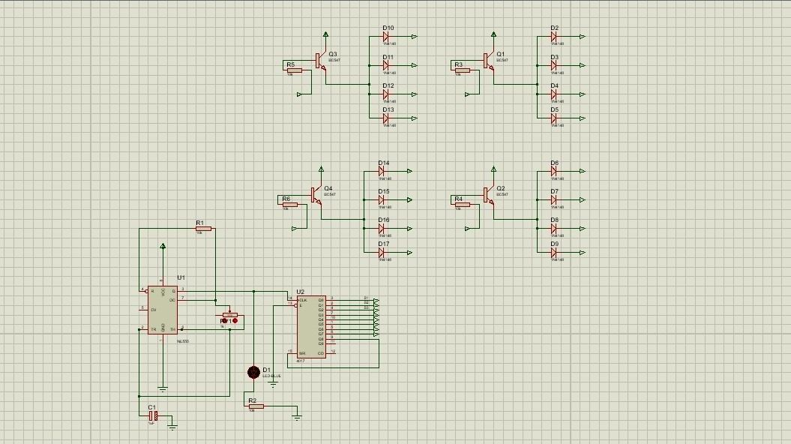
B. Outputs:
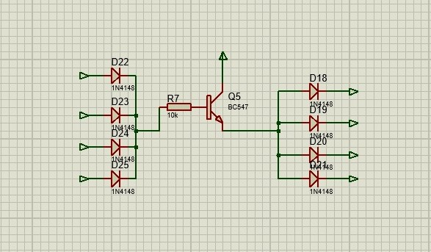
VI. Implementation Details
- Clock Generation: The 555 timer serves as the core of the system, generating consistent clock pulses.
- Sequential Logic: Counters ensure accurate transitions between light states.
- Control Logic: Verifies that only one green light is active at any given time.
- Assembly: The circuit is assembled on a breadboard, allowing for easy modifications during testing.
- Power Supply: A stable DC source with voltage regulators powers the system.
VII. Testing and Validation
Rigorous testing ensures the system meets performance and safety standards:
- Timing Validation: Use simulation tools to measure light durations and verify compliance with design specifications.
- State Transition Testing: Confirm that transitions occur in the correct sequence without conflicts.
VIII. Challenges and Limitations
- Timing Precision: Component tolerances may introduce minor timing inaccuracies, requiring meticulous calibration.
- Hardware Constraints: Breadboard connections can introduce instability, especially during extended testing periods.
- Scalability: Expanding the system for larger intersections increases complexity and component requirements.
IX. Future Enhancements
- Sensor Integration: Incorporate IR sensors to detect vehicle density and dynamically adjust light timings.
- Wireless Communication: Develop an IoT-based framework to synchronize traffic lights across intersections.
- Microcontroller-Based Design: Replace digital logic components with microcontrollers for greater flexibility and advanced features.
- Backup Power: Include battery backups to ensure uninterrupted operation during power outages.
- AI Integration: Explore machine learning algorithms for predictive traffic management and congestion reduction.
X. References
- S. Willsky, Digital Signal Processing and Control Systems, MIT OpenCourseWare, Massachusetts Institute of Technology, 2011.
- M. Morris Mano, Digital Design: With an Introduction to the Verilog HDL, Pearson Education, 5th Edition, 2013.
- T. L. Floyd, Digital Fundamentals, Pearson, 11th Edition, 2014.
- M. John, Traffic Engineering: Design Principles and Practices, McGraw-Hill Education, 3rd Edition, 2018.
- R. David, Design and Simulation of Sequential Circuits Using Logic Components, International Journal of Circuit Theory and Applications, vol. 35, no. 4, pp. 123–134, 2016.
- Jain, et al., Sensor-Based Traffic Light System for Dynamic Traffic Flow, Proceedings of the International Conference on Intelligent Transportation Systems, IEEE, 2019.
- P. Horowitz and W. Hill, The Art of Electronics, Cambridge University Press, 3rd Edition, 2015.
- Hecht-Nielsen, Artificial Intelligence in Traffic Management, Journal of Intelligent Systems, vol. 45, no. 3, pp. 301–310, 2020.
- Proteus Design Suite, Labcenter Electronics Ltd., Simulation and Design of Electronics Circuits, https://www.labcenter.com
- S. Chen and R. Kumar, IoT Applications in Smart Traffic Management Systems, Advances in IoT, vol. 4, no. 2, pp. 57–66, 2021.

